EUSAS – versatile system motor that meets highest quality demands is now available

From now on, the WEG EUSAS motor is available with IEC 63 to 315 frame sizes and power ratings from 0,12 to 200 kW. Motors are available as integral motors for gearboxes and as standard induction motors in two-pole, four-pole and six-pole versions with mounting positions B3, B5 and B14. This modular EUSAS motor (Europe, USA and Asia) was jointly developed further by WEG and its subsidiary Watt Drive. It is the first to combine the energy-efficient WEG motor technology with Watt Drive’s proved and tested MAS modular gear unit system and can be used worldwide.

The specially designed wide-range winding, with each motor’s winding divided into two part windings with a total of twelve leads, provides the EUSAS motor with a large range of wiring options on the nine-bolt terminal board. This allows the motor to be wired for up to four different voltage level (star, delta, double star or double delta) configurations, which makes it highly versatile for the world market. Certifications according to CE, CSA, UL and EAC (replaces GOST) standards guarantee worldwide applicability.

Furthermore, the motors are optimally suited for operation with electronic speed control. Using the 87/100/120 Hz voltage/frequency characteristic, they can be controlled without special windings in frequency inverter operation mode. As a result, the motor can double its useful output power without being overloaded. Bimetal switch and PTC thermistor provide thermal protection by default.

Standard motors are designed according to protection IP55, cooling method IC 411 (self-ventilation) and thermal class F. However, the nominal temperature rise of the motor corresponds to thermal class B. This provides a safety margin for overloads or increased winding life. When operating at temperature rise according to thermal class F, the motors are suitable for ambient temperatures from -20 to +60°C. For use in areas of high humidity, a special insulation is available.

The new EUSAS motor is based on the proved and tested modular MAS system from Watt Drive and is specifically designed for the mounting of a wide variety of motor modules. The available mechanical motor options include spring-loaded brakes, encoder systems, forced cooling, backstops and alternative connection technology for the terminal box. The motor modules can be equipped quickly and easily according to customer requirements, either separately or in combination. This increases application flexibility and ensures short delivery times.

Furthermore, these motors have been integrated into the user-friendly web product configurator “cat4CAD” for an easy and interactive product selection: http://www.wattdrive.com/en/e-catalog-cat4cad/online-version.html

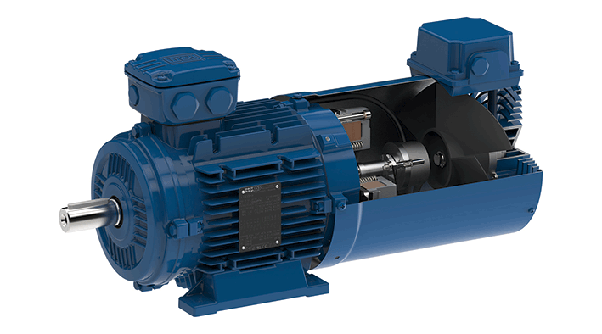

Figure 1: Global flexibility: New modular EUSAS motor

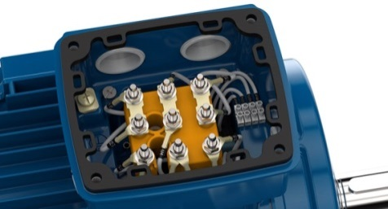
Figure 2: The nine-bolt terminal board provides a wide range of wiring options

