WEG Drives for High-pressure Piston Compressor Systems

WEG is a worldwide leading manufacturer of medium and high voltage motors, which come into use in most diverse fields in the industry. It is only recently that a project could be realised with company LMF, the leading Austrian manufacturer of high-pressure piston compressor systems for air, natural gas, as well as technical and industrial gases, in which explosion-proof WEG motors are driving reciprocating piston compressors.

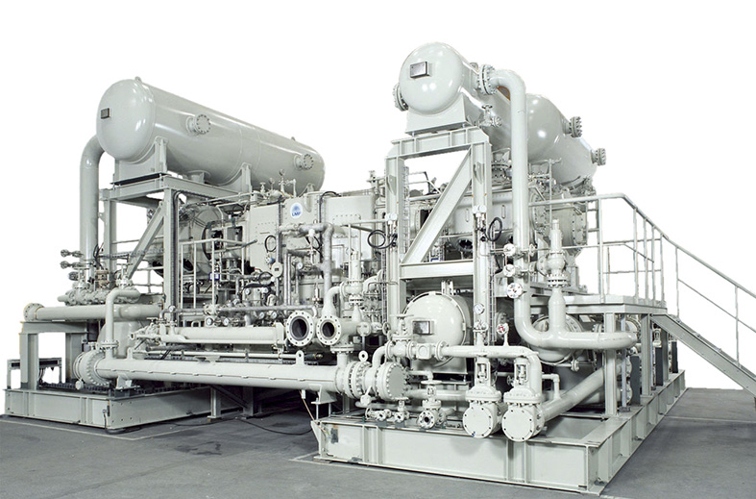
Picture 1: LMF compressor plant

The reliable WEG drives of the H-line of higher protection types and high starting torque, are especially suited for demanding compressor applications (see picture 1). Those medium voltage motors of the type HGF 630C are manufactured in the Portuguese Maia, the WEG’s competence centre for the manufacturing of explosion-proof medium and high voltage motors.

Specification of the implemented WEG motors:
- Quantity: 3
- Power: 835 kW
- Number of poles: 12
- Voltage: 3300 V
- Ignition protection type: Ex nA
- Oscillating speed: < 1 mm/s
- Further features: Temperature protection, auxiliary heating system, overvoltage protection

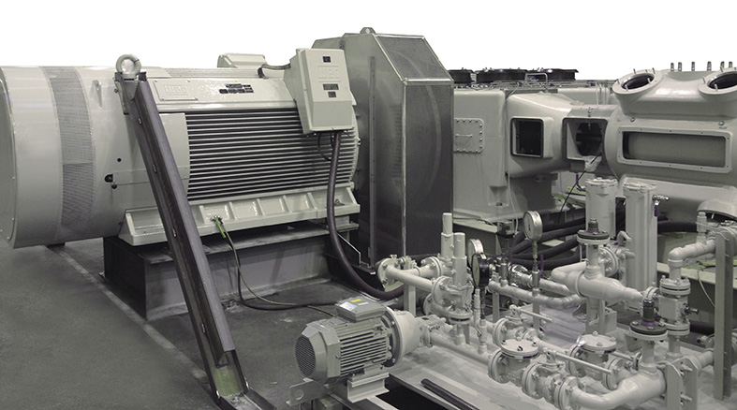
Picture 2: WEG Motor HGF 630C (test run at LMF)

Extraction of process gas at crude oil processing:
Formerly the process gas (balance gas) that was extracted at the crude oil processing was directly released into the atmosphere or flared. On compressing that gas to a higher pressure, it can again be added to the process.
The compressors (2 pieces in use, 1 piece in standby/backup) have the task to compress the process gas from an original pressure of 1.013 bar to 6.14 bar in the end. The three compressors are provided with the process gas by evaporators with an original pressure of 1.013 bar. It is then compressed in a two-stage compressing process to 6.14 bar of output pressure.

Technical Data of the High-pressure piston compressor systems:

- 3 reciprocating piston compressors for balance gas (propane, butane,… + H2S)
- Design 4-axle/2-staged (piston diameter 880mm & 520mm)
- Delivering quantity: 19,600 kg/h
- Suction pressure: 1.013 bar
- End pressure: 6.14 bar
- Installation site: Kuwait
- Installation: open-air, roofed
- Explosion protection: Zone 2, IIA, T3
- Ambient temperature: -3°C up to +55°C
- Humidity: 6 – 100%

Further WEG products of medium and high voltage motors:
With the following series WEG offers a complete product programme in the range of medium and high voltage, with a power spectrum of 90 kW up to 20 MW, perfectly adapted to the customers requirements. The H- and M-line are available as well in NEMA design. WEG medium and high voltage motors are used for the drive of ventilation, pumps, compressors, crushers, refiners and mills. With the experiences of the last centuries all series have been constantly further developed and permanently adjusted to customers’ requirements and the demands of the market.

W22 MV (Medium voltage)
This series is essentially based on the constructive features of the W22 low voltage series and thus offers all the well-known technical advantages. The spectrum of this series comprises the power from 90 up to 440 kW in 2-, 4-, 6- and 8-poled design, for voltages of 2.3 kV up to 6.6 kV at 50 and 60 Hz. Available sizes are 315 and 355.

H-line motors
The H-line is the perfect complement for the W22 MV motor for the higher power range, as well as higher voltages. The H-line motors are either available with self-cooling (IC411) or forced cooling (IC416). The power range of this series begins with 90 kW and goes up to 3,150 kW. The voltage ranges from 2.3 kV up to 11 kV, at 50 and 60 Hz each. The H-line is available with a size of 315 up to 630. So this is the worldwide only motor that still can be offered with a grey cast iron housing in size 630.

M-line motors
Motors of the type M-line (see picture 3) are a further complement of the aforementioned motor series. M-line asynchronous motors can as well be designed as squirrel cage or as slip ring. The housing of the motor is of grey cast iron in the sizes from 280 to 560. Sizes of 630 to 1800 are purely welded constructions. Voltage ranges from 2.3 kV up to 13.8 kV are in 50 and 60 Hz design and in 2-, 4-, 6-, 8-, 10- and 12-poled design. A standard cooling functions an air-to-air heat exchanger, mounted on the motor. Further cooling types (i.e. air-to-water heat exchanger) are available as option.

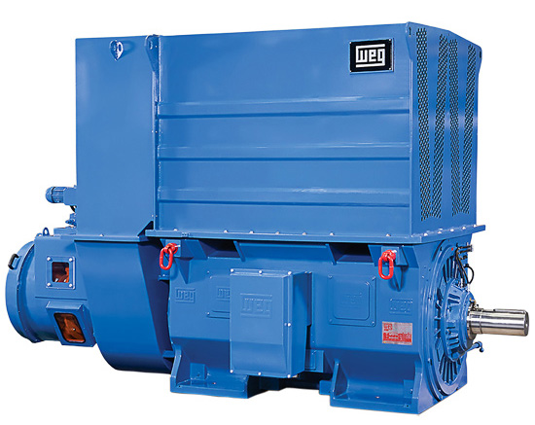
Picture 3: M-Line

