Servo drive model adds momentum to the SPS trade fair

From November 25th to 27th, visitors to Stand 250, Hall 3 can learn more about how WEG supports engineers through integrated automation solutions.

At this year’s SPS IPC Drives exhibition, drive specialist WEG is presenting a dynamic servo drive model as an integrated automation solution for the first time in Europe. The model shows five synchronized servo drives, consisting of servo controllers SCA06 and servo motors SWA that achieve excellent precision in their positioning tasks. Additional automation components from WEG, including contactors, circuit breakers, an HMI, a touchscreen, motor protection switches and pushbuttons, are also integrated into the model.

Other highlights on WEG’s stand include the new MW500 frequency inverter that simplifies installation and motor start-up, thereby reducing costs. The drives can be attached directly to motor terminal boxes (without any special protective housing) or to the wall, which increases the flexibility of the installation.
Two product combinations are further proof of WEG’s system expertise and ability to provide solutions for a multitude of application scenarios: one combining a Watt Drive geared motor with an MW500 frequency inverter, the other combining the geared motor with a servo motor.

Additionally, WEG is expanding its automation portfolio in Europe with an extended output power range: The rated power range of the CFW500 variable speed drive series for low-voltage applications has been raised from 7,5 up to 15 kW, whereas the maximum rated power of the variable speed drive MVW01 has been raised from 6.000 to 16.000 kW for two voltage ranges.

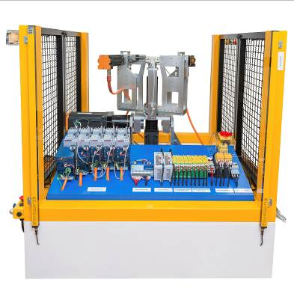

Image 1: The dynamic servo drive model serves as an example for WEG’s ability to provide servo drives for demanding positioning tasks as well as complete automation solutions

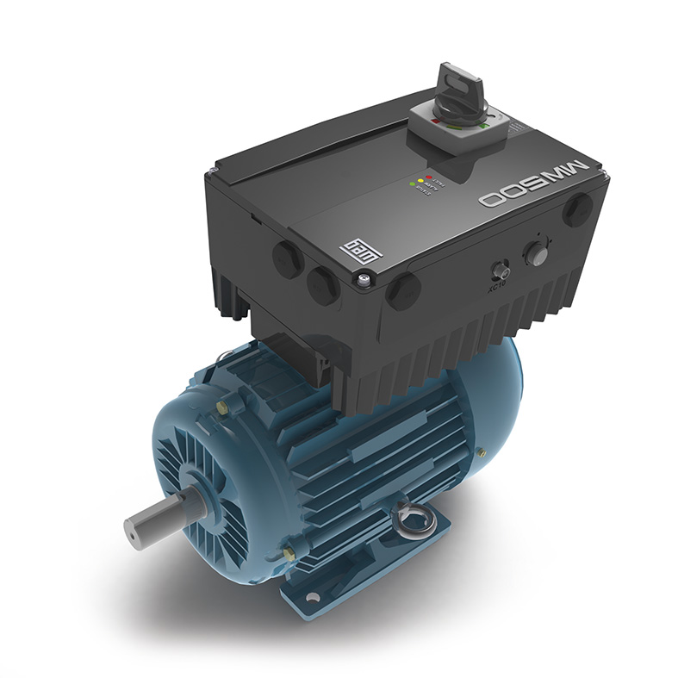
Image 2: The MW500 frequency inverter can be attached directly to motor terminal boxes or to the wall

