**WEG expands CFW11 variable speed drive range**

WEG, a leading global manufacturer of drive technology, has added a new powerful and versatile frame size H variable speed drive to its CFW11 series to help optimise processes and boost productivity in high power level applications. Available in two versions - covering the voltage range from 380 to 690 V and the power range from 450 to 710 kW in normal operation - the CFW11 in frame size H can control both squirrel-cage and permanent-magnet motors and is designed for normal and heavy load operation in a wide range of industrial and commercial applications.

WEG’s CFW11 drive is easy to configure and operate. Users can configure device parameters simply, either individually or in defined groups for specific applications, and the control panel features a user-friendly navigation and control with programmable buttons. In addition, a guide helps users through programming, helping them save installation and setup times.

Many plug-in extension modules are available for adapting the variable speed drives to users’ needs and are automatically recognised by the device for convenient plug-and-play operation. The standard model also features an integrated micro-PLC, enabling users to program their own applications at any time using the included WLP software for relay logic.

CFW11 variable speed drives support both voltage vector (VVW) control and control using U/f control characteristics. WEG's unique Vectrue technology provides outstanding response characteristics, precise torque and speed control, accurate positioning and high overload capacity. For use in safety-critical applications, WEG also integrates numerous protection functions with fault and alarm indications in the variable speed drives, as well as EN ISO 13849-1 safe shutdown – Safe Torque Off (STO) Category 3/ PL d – as an optional module.

The CFW11 enclosure is rated IP20 in the standard version, and an IP54 version is optionally available with through-hole PCB assembly for the power stage. The CFW11 series supports the Modbus RTU (RS232 and RS485), CANopen, DeviceNet, Proﬁbus DP/DPV1, Proﬁnet, Modbus TCP, Ethernet/IP, Ethercat and BACnet communication protocols as standard. An integrated USB port allows device parameter data to be backed up quickly and easily on a flash memory card or transferred to other devices.

“Our CFW11 VSDs are highly versatile and easy to use and are designed to help users across a wide range of industrial and commercial applications operate motors more efficiently according to the latest energy efficiency regulations,” says Marek Lukaszczyk, European & Middle East Marketing Manager at WEG. “The new frame size H version has been introduced to make the CFW11 even more versatile meeting the needs of high power level applications.”

For further information on WEG visit [www.weg.net/uk](http://www.weg.net/uk).

**Image captions**

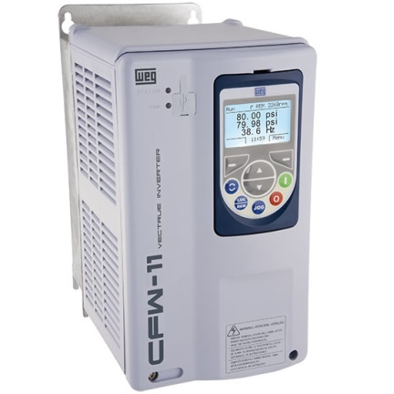

**WEG3714_Image1:** WEG expands its CFW11 series of variable speed drives with frame size H for the top end of the power range

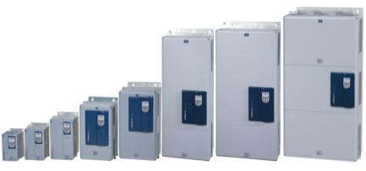

**WEG3714_Image2:** The expanded CFW series now covers voltages from 220 to 690 V and power levels from 1.1 kW to 1,186 kW.

Follow WEG at  Description: Description: Description: Description: Description: Description: Description: Description: Description: Description: Description: Description: Description: Description: Description: Description: Description: Description: Description: Description: Description: Description: Description: Description: Description: Description: Description: Description: Description: Description: Description: Description: Description: Description: Description: Description: Description: Description: Description: Description: Description: Description: Description: Description: Description: Description: Description: Description: Description: cid:image009.jpg@01CE8155.D3CFD760   Description: Description: Description: Description: Description: Description: Description: Description: Description: Description: Description: Description: Description: Description: Description: Description: Description: Description: Description: Description: Description: Description: Description: Description: Description: Description: Description: Description: Description: Description: Description: Description: Description: Description: Description: Description: Description: Description: Description: Description: Description: Description: Description: Description: Description: Description: Description: Description: Description: cid:image011.jpg@01CE8155.D3CFD760  Description: Description: Description: Description: Description: Description: Description: Description: Description: Description: Description: Description: Description: Description: Description: Description: Description: Description: Description: Description: Description: Description: Description: Description: Description: Description: Description: Description: Description: Description: Description: Description: Description: Description: Description: Description: Description: Description: Description: Description: Description: Description: Description: Description: Description: Description: Description: Description: Description: cid:image010.jpg@01CE8155.D3CFD760

**Ends**

## About WEG

WEG is one of the largest global manufacturers of electric equipment, having five main Business Units: Motors, Energy, Transmission and Distribution, Automation and Coatings.  The company employs over 30,000 people worldwide and in 2014 achieved global sales of R$7.8 billion, representing success across a wide range of product groups.  These include the latest generation of transformers, LV control gear, generators, gear motors, inverter drive systems, soft starters, LV/MV and HV motors, ATEX-compliant explosion proof motors, smoke extraction motors and full turnkey systems.

Its power generation, transmission and distribution solutions enable those across many industries, especially in the oil & gas, water, power distribution, chemical and petrochemical markets, to operate more efficiently, and to reduce energy usage, carbon emissions and environmental impact. In addition, WEG provides full solutions for renewable energy projects, producing complete wind turbine systems.

**Editorial Contact**

Marco Giudici, Technical Publicity  
Tel: +44 (0)1582 390991   
Email: [mgiudici@technical-group.com](mailto:mgiudici@technical-group.com)

**Company Contact**

Marek Lukaszczyk, WEG (UK) Ltd   
Tel: +44(0)1527 513800 Fax: +44(0)1527 513810  
Email:  [wegsales@wegelectricmotors.co.uk](mailto:sclarke@technical-group.com)

Web: [www.weg.net](http://www.weg.net)/uk