**Ultra efficient: WEG's new permanent-magnet motor surpasses the IE4 standard**

***Low-voltage motors in energy efficiency class IE5 should have approximately 20% lower losses than IE4 motors. WEG has now launched a permanent-magnet motor that fulfils this demanding requirement, making it one of the first to qualify for the IE5 Ultra Premium Motor designation.***

WEG, a leading international supplier of drive technology, has again raised the bar for energy efficiency with its new permanent-magnet motor in the W22 series. Already a pioneer in this area with the introduction of the W22 Super Premium IE4 three-phase induction motors in late 2012, WEG is further consolidating its leadership with even more efficient permanent-magnet synchronous motors.

With losses roughly 20% lower than Super Premium models, it is among the first Ultra Premium motor on the market that fulfils the present criteria for the potential IE5 energy efficiency class. This makes the W22 permanent-magnet motor one of the most efficient electric motors currently available world-wide.

Using innovative design, the W22 permanent-magnet motor combines unique high efficiency with compact size. Along with raising efficiency, WEG optimised motor performance to achieve lower noise and vibration emissions as well as especially low maintenance.

The new permanent-magnet motors in the W22 series are AC synchronous motors driven by CFW11 frequency inverters. The CFW11 frequency inverters have specific software for open-loop speed control of permanent-magnet motors. The software is based on a special drive strategy designed to maximise the torque per ampere. This approach makes the combination of a W22 permanent-magnet motor and a CFW11 frequency inverter a very efficient drive system that is able to deliver constant torque over the entire operating range.

With motors in efficiency classes IE2 to IE5, soft starters, servo technology and frequency inverters, WEG now offers the broadest portfolio of drive solutions to help manufacturers raise the efficiency of their systems, improve their processes and lower their operating costs.

“Energy efficiency is high on the industrial agenda, with the EU Motor Efficiency Regulations coming into effect in 2015, stipulating that IE3 induction motors, or alternatively IE2 motors driven by frequency inverters, must be used in industrial applications,” says Marek Lukaszczyk, European Marketing Manager at WEG. “We’re delighted to far exceed the regulations with our new permanent-magnet motor and it’s another example of how we’re pushing boundaries and going one step further to help engineers maximise the energy efficiency of their processes.”

More information on WEG products is available at [www.weg.net](http://www.weg.net/)/uk

**Figure caption:**

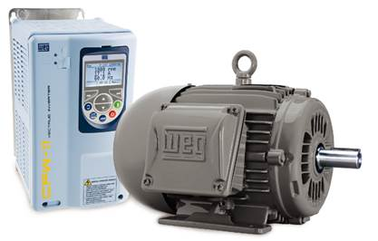

**WEG2177:** One of the most energy-efficient motors currently available:WEG's new permanent-magnet motor

## About WEG

WEG is a major global player in the power distribution, automation and control sector. The company’s global sales now exceed US $3-billion, representing increasing global success across a wide range of product groups. These include the latest generation of transformers, LV control gear, generators,  gear motors, inverter drive systems, soft starters, LV/MV and HV motors, ATEX- compliant explosion proof motors, smoke extraction motors and full turnkey systems.

**Editor Contact**

Julia Swan, Technical Publicity  
Tel: +44 (0)1582 390980  
Email: [jswan@technical-group.com](mailto:jswan@technical-group.com)

**Company Contact**

Marek Lukaszczyk, WEG Electric Motors (UK) Ltd   
Tel: +44(0)1527 513800 Fax: +44(0)1527 513810

Web: [www.weg.net](http://www.weg.net)  
Email: [wegsales@wegelectricmotors.co.uk](mailto:sclarke@technical-group.com)